What is Agentic AI? A Beginner’s Guide - Part 1 4
Objective: 4
1. Introduction 4
2. What Is Agentic AI? 4
Defining Agentic AI 4
Core Components of Agentic AI 5
Agentic AI in Practice 6
3. Applications of Agentic AI 7
1. Robotics and Automation 7
2. Autonomous Vehicles 7
3. Enterprise Applications 8
4. Healthcare and Medicine 9
5. Customer Service 10
Why These Applications Matter 11
What is Agentic AI? A Beginner’s Guide - Part 2 11
4. How Agentic AI Differs from Traditional AI 11
1. Nature of Task Execution 11
2. Adaptability 12
3. Proactivity 12
4. Goal-Oriented Behavior 12
5. Learning and Feedback 13
6. Interaction with Humans and Systems 13
5. Challenges and Considerations 15
1. Complexity in Development 15
2. Data Dependence and Quality 15
3. Computational Resource Requirements 15
4. Ethical and Governance Issues 15
5. Integration into Existing Systems 16
6. Security and Reliability Risks 16
7. Unintended Consequences 16
8. Cost of Implementation 16
Balancing Innovation with Responsibility 17
6. Conclusion 17
Take the Next Step 18
Looking Ahead 18
Additional Media Suggestions: 18
Understanding Agentic AI: Core Components Explained 19
Objective: 19
1. Introduction 19
2. Understanding Agentic AI Component 19
3. Core Components of Agentic AI 19
1. Perception 20
2. Reasoning 20
3. Action 20
4. Feedback Loop 21
4. Interconnectivity of Core Components: Building a Cohesive Agentic AI System 21
Dependencies Between Perception, Reasoning, Action, and Feedback 21
Challenges in Component Integration 21
Techniques to Improve Inter-Component Efficiency 21
Conclusion 22
Key Technologies Powering Agentic AI 23
Objective 23
Introduction 23
Foundation Models and Large Language Models (LLMs) 23
How LLMs Power Agentic AI 23
Real-World Applications of LLMs in Agentic AI 24
Reinforcement Learning and Decision-Making Algorithms 24
How Reinforcement Learning Powers Agentic AI 24
Key Reinforcement Learning Techniques 24
Real-World Applications of RL in Agentic AI 24
Knowledge Graphs and Ontologies 25
How Knowledge Graphs and Ontologies Empower Agentic AI 25
Key Components of Knowledge Graphs and Ontologies 25
Applications in Agentic AI 25
Multi-Modal Perception Technologies 25
How Multi-Modal Perception Enhances Agentic AI 25
Key Components of Multi-Modal Perception 26
Applications in Agentic AI 26
Cognitive Architectures and Planning Systems 26
Role in Agentic AI 26
Key Components of Cognitive Architectures 26
Planning Systems and Algorithms 27
Applications in Agentic AI 27
Large-Action Models (LAMs) and Autonomous Execution Frameworks 27
Role in Agentic AI 27
Core Components of LAMs 27
Autonomous Execution Frameworks 27
Applications in Agentic AI 28
Edge AI and Real-Time Processing 28
Role in Agentic AI 28
Core Components of Edge AI 28
Applications in Agentic AI 28
Agentic AI Tooling and Development Frameworks 28
Role in Agentic AI Development 28
Key Development Frameworks and Tools 29
Applications in Agentic AI 29
Conclusion and Next Steps 29
Summary of Key Technologies 29
Next Steps 29
Agentic AI in Action: Building with CrewAI - Part 1 30
Objective 30
Introduction 30
Understanding CrewAI and Its Capabilities 30
What is CrewAI? 30
Key Capabilities of CrewAI 30
Core Concepts in CrewAI 30
Setting Up Your Development Environment 31
Initializing a New CrewAI Project 32
Understanding the Generated Project Structure 32
Demonstrating Core Agentic AI Concepts with CrewAI 33
Single-Agent Example: Market Research 33
Conclusion 42
Agentic AI in Action: Building with CrewAI - Part 2 43
Objective 43
Introduction 43
Expanding to a Content Creation Crew for EduVerse 43
Advanced Use Cases in CrewAI with Multi-agents Systems 46

What is Agentic AI? A Beginner’s Guide - Part 1

Objective
Ever wondered how AI can move beyond simple tasks to truly autonomous action? We’re diving into the heart of Agentic AI, exploring its core principles and real-world impact. Discover how it’s revolutionizing AI, and why it’s not just another buzzword—it’s the future. Get ready to see AI in a whole new light.
Medium public short description:
Discover how Agentic AI enables true autonomy, reshaping AI’s future beyond simple tasks—this is more than a buzzword.

1. Introduction
Imagine an AI system that doesn’t just follow commands or respond to queries but takes initiative, adapts to unexpected changes, and solves complex problems in real-time. Picture an autonomous robot navigating a bustling warehouse, optimizing its route as new obstacles appear, or a virtual assistant that not only schedules meetings but actively suggests strategies to improve your productivity. Welcome to the world of Agentic AI, a transformative leap in the evolution of artificial intelligence.
As the demand for intelligent systems grows, so does the need for autonomy. Traditional AI systems excel at performing narrow, predefined tasks like recognizing faces in photos or recommending your next favorite movie. But they falter when faced with unpredictable environments or multi-step goals requiring strategic decision-making. This is where Agentic AI steps in—bringing the ability to perceive, reason, and act independently in dynamic settings.
In this article, we’ll explore what sets Agentic AI apart from traditional AI. You’ll learn:
- The core principles that define Agentic AI,
- Its wide-ranging applications across industries, and
- How it differs fundamentally from traditional AI systems.
By the end, you’ll have a clear understanding of why Agentic AI is a pivotal development in shaping the future of technology.

2. What Is Agentic AI?
Agentic AI represents a significant evolution in the design and capabilities of artificial intelligence systems. Unlike traditional AI, which is often confined to narrow, predefined tasks, Agentic AI systems are designed to operate autonomously in dynamic environments, making decisions and taking actions to achieve specific goals.

Defining Agentic AI
At its core, Agentic AI refers to autonomous systems that exhibit the following key characteristics:
- Autonomy: They function independently without requiring constant human intervention.
- Proactivity: They anticipate and act upon opportunities or challenges to achieve their objectives.
- Adaptability: They adjust their behavior in response to changes in the environment.
- Goal-Oriented Behavior: They are purpose-driven, focusing on achieving complex, often multi-step goals.
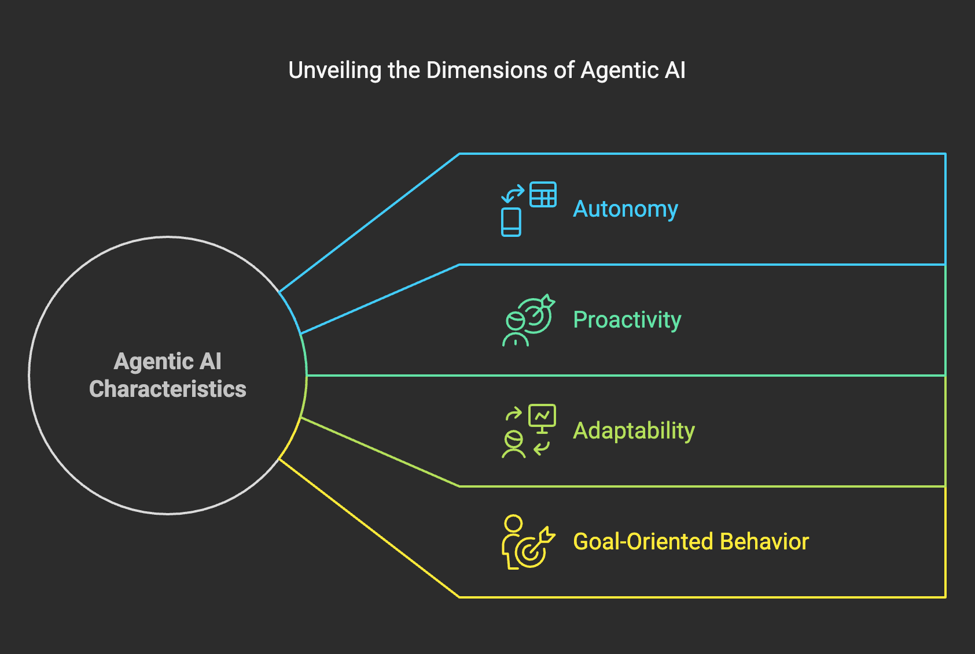
Agentic AI systems are built around the concept of intelligent agents—software or robotic entities capable of perceiving their environment, reasoning about the information they collect, and acting to influence that environment. These systems combine elements of perception, decision-making, and execution into a cohesive framework.

Core Components of Agentic AI
To fully grasp Agentic AI, it's helpful to break it down into its fundamental building blocks:
- Perception:
  - The ability to sense and interpret the environment through inputs such as visual data, audio signals, or sensor readings.
  - Example: A self-driving car detecting road signs, pedestrians, and traffic conditions.
- Reasoning:
  - The capacity to process information, weigh options, and make decisions.
  - Example: A warehouse robot determining the most efficient route to retrieve an item.
- Action:
  - The execution of tasks or behaviors to achieve objectives.
  - Example: A delivery drone autonomously flying to its destination while avoiding obstacles.
- Feedback Loop:
  - Continuous learning and adaptation based on outcomes.
  - Example: An AI-powered customer service agent improving responses over time by analyzing past interactions.
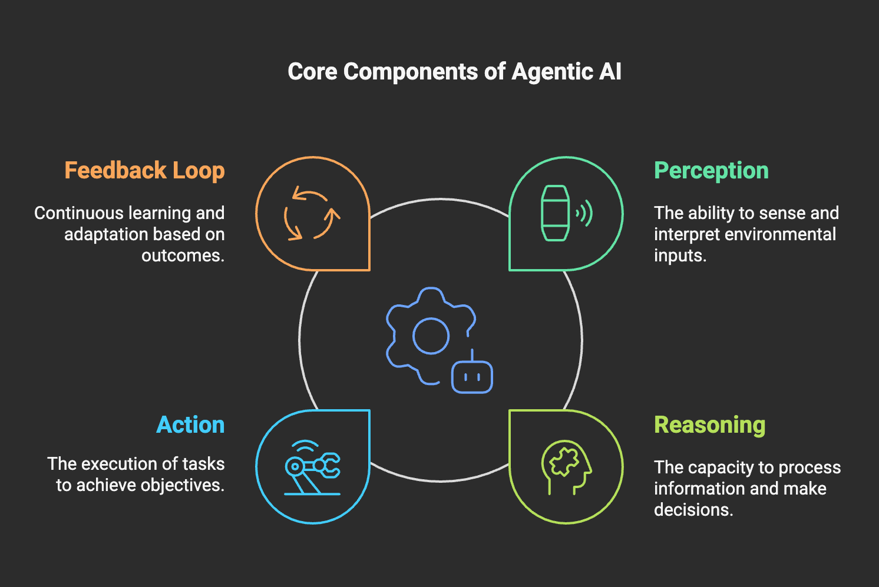

Agentic AI in Practice
The integration of these components enables Agentic AI systems to perform tasks that were previously unimaginable for traditional AI. For example:
- An agricultural drone that not only identifies crop health issues but also takes corrective actions like spraying fertilizer or pesticides.
- A financial AI agent that monitors market trends, predicts opportunities, and executes trades autonomously.
By combining these elements, Agentic AI bridges the gap between static, narrowly focused AI and the versatile, goal-driven capabilities of autonomous systems.

3. Applications of Agentic AI
The transformative potential of Agentic AI is evident across a wide range of industries and use cases. By combining autonomy, adaptability, and goal-oriented behavior, these systems excel in dynamic, real-world environments, addressing challenges that require more than static, predefined solutions.

1. Robotics and Automation
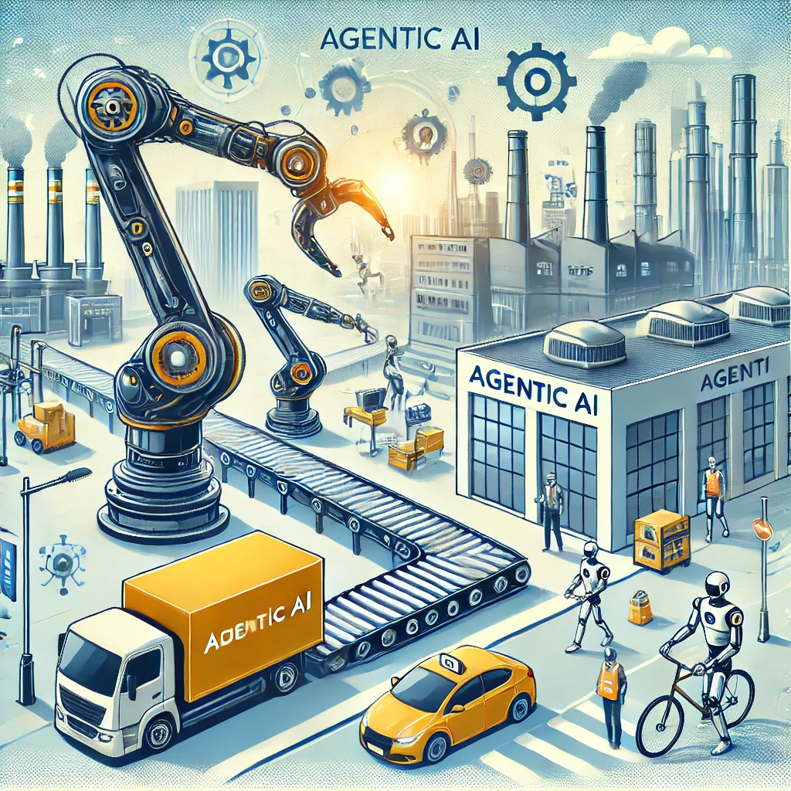
- Industrial Robotics:
  - Manufacturing and logistics are at the forefront of Agentic AI applications. Robots equipped with Agentic AI can autonomously manage assembly lines, handle materials, and adapt to changes such as equipment failures or variations in production.
  - Example: A robotic arm on a factory floor that adjusts its speed and grip based on the material's properties.
- Service Robotics:
  - From cleaning robots in commercial spaces to autonomous delivery drones, Agentic AI enables machines to handle tasks in dynamic and unpredictable environments.
  - Example: Delivery robots navigating crowded city streets while adjusting to pedestrians and traffic.

2. Autonomous Vehicles

- Self-Driving Cars:
  - Agentic AI is the backbone of autonomous vehicle systems, allowing cars to perceive their surroundings, make real-time decisions, and navigate safely through complex traffic scenarios.
  - Example: A self-driving car rerouting itself to avoid an unexpected roadblock while considering time and fuel efficiency.
- Drones and UAVs:
  - Unmanned aerial vehicles (UAVs) equipped with Agentic AI are revolutionizing industries like agriculture, surveillance, and logistics.
  - Example: An agricultural drone that maps crop health and applies fertilizers where needed.

3. Enterprise Applications

- Workflow Automation:
  - Intelligent agents streamline business processes, from automating repetitive tasks to optimizing resource allocation.
  - Example: An AI agent that autonomously schedules meetings, reallocates team resources based on deadlines, and resolves conflicts in project timelines.
- Decision Support:
  - Agentic AI can enhance enterprise decision-making by analyzing vast datasets, forecasting outcomes, and recommending strategic actions.
  - Example: A financial AI agent that monitors market trends, predicts opportunities, and executes trades autonomously.

4. Healthcare and Medicine
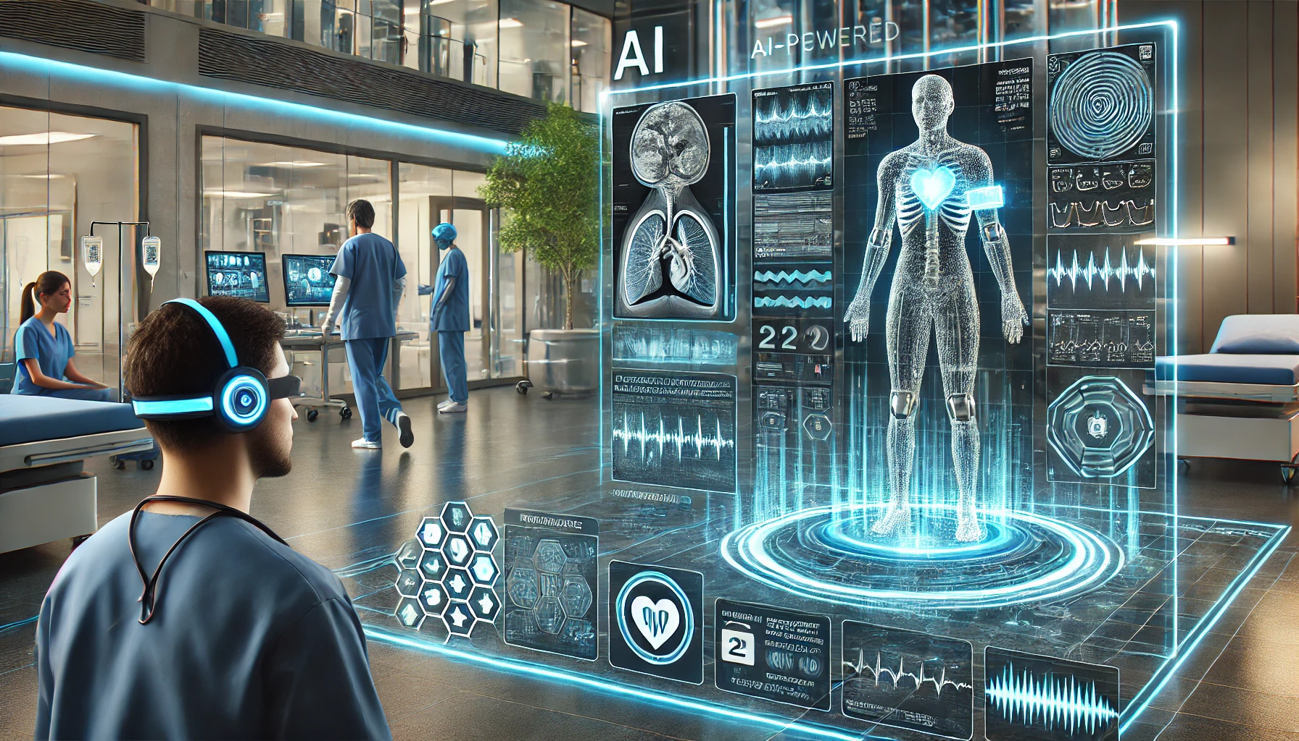
- Diagnostics and Treatment Planning:
  - Agentic AI systems assist in identifying diseases, recommending treatments, and personalizing care for patients.
  - Example: A diagnostic AI agent analyzing medical images to detect abnormalities and suggest next steps for treatment.
- Patient Monitoring:
  - Autonomous systems monitor patients in real-time, alerting caregivers to critical changes and suggesting interventions.
  - Example: A wearable device powered by AI that tracks vital signs and autonomously calls for help in emergencies.

5. Customer Service

- Intelligent Virtual Assistants:
  - Agentic AI transforms customer service by providing responsive, context-aware support that goes beyond scripted interactions.
  - Example: A virtual agent that not only answers customer queries but also detects sentiment and proactively resolves potential issues.
- Omnichannel Support:
  - AI-powered agents seamlessly manage customer interactions across email, chat, and phone, ensuring consistent and personalized experiences.
  - Example: An agent that tracks customer history and anticipates their needs across all touchpoints.

Why These Applications Matter
Agentic AI systems go beyond solving isolated problems; they enable innovation and efficiency in domains that demand autonomous, adaptive, and goal-driven solutions. By integrating perception, reasoning, and action, they open up possibilities for tackling challenges that are too complex or dynamic for traditional AI.

What is Agentic AI? A Beginner’s Guide - Part 2

Objective
Agentic AI vs. Traditional AI: What’s the real difference, and why should you care? We break down the key distinctions, revealing how Agentic AI is a game-changer, not just a new label. See how it’s setting the stage for the next wave of AI innovation.

Medium public short description:
Part 2 explores how Agentic AI differs from traditional AI—and why it marks a key shift in the evolution of intelligent systems.

Introduction
In part 1 of this introductory series of articles, we mentioned the foundations and core components of Agentic AI. But how does it compare to the AI systems we already know and what is the added value?

4. How Agentic AI Differs from Traditional AI
To appreciate the unique potential of Agentic AI, it’s essential to understand how it diverges fundamentally from traditional AI systems. While both types of AI aim to solve problems and enhance efficiency, their design philosophies, capabilities, and applications differ significantly.

1. Nature of Task Execution
- Traditional AI:
  - Typically designed for narrow, predefined tasks, traditional AI systems are highly specialized. They excel in specific domains but cannot operate outside their programmed scope.
  - Example: A machine learning model trained to recognize cats in images cannot classify other objects or adapt to new tasks.
- Agentic AI:
  - Operates autonomously in dynamic environments, pursuing goals that may require a combination of tasks and the ability to adapt.
  - Example: An Agentic AI system managing warehouse logistics could switch between inventory tracking, optimizing robot routes, and responding to equipment malfunctions.

2. Adaptability
- Traditional AI:
  - Lacks the ability to adapt to changes in real-time. If the input or environment varies significantly from its training data, traditional AI may fail.
  - Example: A customer service chatbot providing scripted responses struggles when confronted with nuanced or complex queries.
- Agentic AI:
  - Designed for flexibility, Agentic AI systems can learn and adjust to unexpected situations without human intervention.
  - Example: A self-driving car dynamically rerouting itself in response to sudden road closures or adverse weather conditions.

3. Proactivity
- Traditional AI:
  - Reactive in nature, traditional AI systems respond only when prompted. They do not take initiative to identify or solve problems independently.
  - Example: A recommendation system suggesting products based on user input but not initiating engagement.
- Agentic AI:
  - Proactive systems that anticipate needs and act without explicit instructions. They analyze their environment, predict outcomes, and make decisions to achieve objectives.
  - Example: A financial AI agent monitoring market conditions and autonomously adjusting a portfolio to mitigate risks.

4. Goal-Oriented Behavior
- Traditional AI:
  - Focused on executing individual tasks efficiently, with no overarching objectives beyond the specific task it was designed for.
  - Example: An image recognition AI tagging objects in photos without understanding the broader purpose of the task.
- Agentic AI:
  - Operates with a purpose, often navigating multi-step processes to achieve high-level goals. These systems integrate decision-making and execution into a cohesive framework.
  - Example: A disaster response AI coordinating drones, rescue teams, and supply chains to optimize relief efforts in real time.

5. Learning and Feedback
- Traditional AI:
  - Relies heavily on supervised learning and predefined datasets. Updating or improving the system often requires retraining with new data.
  - Example: A spam filter retrained periodically with new labeled data to detect emerging spam patterns.
- Agentic AI:
  - Employs continuous learning mechanisms, often in real-time, to improve its performance based on feedback from its actions and outcomes.
  - Example: An autonomous robot refining its navigation algorithms after encountering unforeseen obstacles in a warehouse.

6. Interaction with Humans and Systems
- Traditional AI:
  - Operates as a tool that complements human actions but typically requires clear instructions and manual oversight.
  - Example: A virtual assistant setting reminders or sending emails based on direct user commands.
- Agentic AI:
  - Functions as a collaborator, capable of understanding context, making independent decisions, and coordinating with other agents or systems.
  - Example: An AI project manager that autonomously assigns tasks, monitors team progress, and resolves scheduling conflicts.

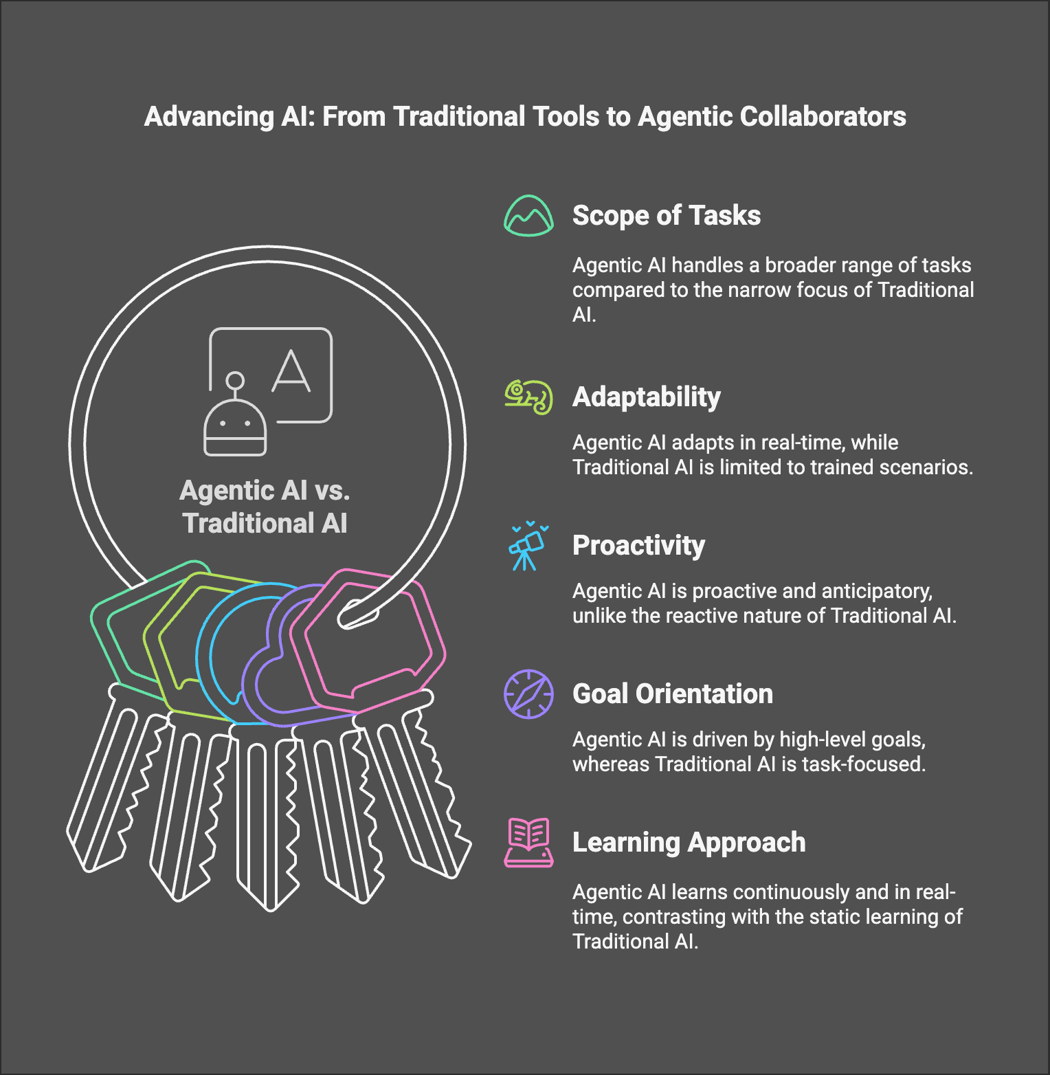
The evolution from traditional AI to Agentic AI reflects a shift toward systems capable of autonomy, adaptability, and decision-making. These differences make Agentic AI a game-changing technology, enabling applications that go beyond the limitations of traditional approaches.
It is worth noting, though, that both Traditional AI and Agentic AI can be combined. For instance, a Traditional AI tool for recognizing images to diagnose diseases (e.g., detecting tumors in MRI scans) can serve as input over time for an Agentic AI, which could analyze patterns, connect data points across multiple diagnostic tools, and proactively alert doctors while recommending interventions.
Agentic AI acts as the orchestrator, making high-level decisions, learning dynamically, and adapting based on goals, while Traditional AI provides foundational intelligence, such as pattern recognition, language processing, and forecasting

5. Challenges and Considerations
While Agentic AI offers transformative benefits, its adoption and implementation come with notable challenges and considerations. Understanding these obstacles is essential to unlocking the full potential of this technology while mitigating risks.

1. Complexity in Development
Developing Agentic AI systems requires expertise across multiple disciplines, including machine learning, reasoning models, robotics, and software engineering.
- Challenge: The integration of diverse components like perception, decision-making, and action in dynamic environments can be difficult to design and implement.
- Consideration: A modular development approach and robust testing frameworks can help manage this complexity.

2. Data Dependence and Quality
Agentic AI systems rely heavily on high-quality data for training, reasoning, and decision-making.
- Challenge: Inconsistent, biased, or incomplete data can hinder performance or lead to undesirable outcomes.
- Consideration: Establishing rigorous data governance and validation protocols is essential to ensure system reliability and fairness.

3. Computational Resource Requirements
The sophisticated models and algorithms powering Agentic AI demand substantial computational power.
- Challenge: High computational costs can be a barrier to scalability, particularly for smaller organizations or in resource-constrained environments.
- Consideration: Leveraging cloud-based infrastructure or optimizing algorithms for efficiency can mitigate these costs.

4. Ethical and Governance Issues
Agentic AI systems must operate within ethical boundaries to avoid harm or unintended consequences.
- Challenge: Ensuring transparency, accountability, and fairness in decision-making can be challenging, especially in high-stakes applications.
- Consideration: Adopting frameworks for ethical AI, such as bias audits and explainability mechanisms, is critical for trust and compliance.

5. Integration into Existing Systems
Deploying Agentic AI within an organization often requires significant changes to existing infrastructure.
- Challenge: Ensuring seamless integration with legacy systems and workflows can be time-consuming and costly.
- Consideration: A phased implementation strategy, starting with pilot projects, can help minimize disruption.

6. Security and Reliability Risks
Agentic AI systems operating autonomously in open environments are vulnerable to security threats and reliability issues.
- Challenge: Cyberattacks, system failures, or adversarial inputs can compromise system integrity.
- Consideration: Building robust security features and fail-safe mechanisms into AI systems is essential to maintain reliability and trust.

7. Unintended Consequences
The autonomy of Agentic AI can lead to unforeseen outcomes, particularly in poorly defined or complex environments.
- Challenge: Misaligned objectives or insufficient oversight can result in actions that deviate from intended goals.
- Consideration: Continuous monitoring, feedback loops, and mechanisms for human intervention are crucial to maintaining alignment.

8. Cost of Implementation
The development, deployment, and maintenance of Agentic AI systems often involve significant investments in time, talent, and technology.
- Challenge: Organizations may struggle to justify these costs without clear and measurable returns on investment.
- Consideration: Identifying high-impact use cases and demonstrating early wins can help secure buy-in and resources.

Balancing Innovation with Responsibility
While the promise of Agentic AI is immense, its successful adoption requires balancing innovation with responsibility. By addressing these challenges head-on and incorporating thoughtful design and governance, organizations can harness the full potential of Agentic AI while minimizing risks and unintended consequences.
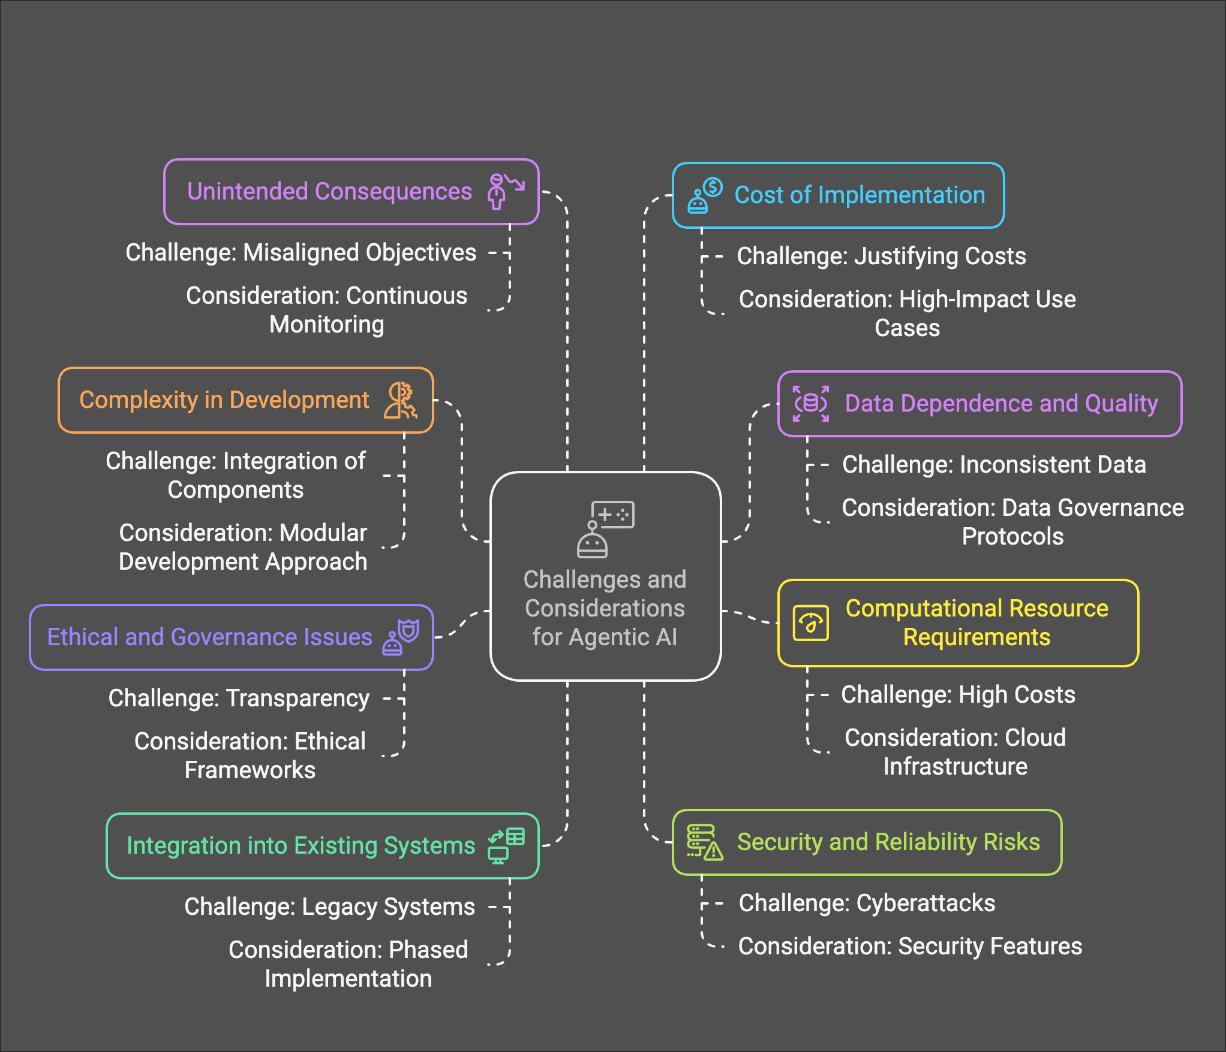

6. Conclusion
Agentic AI represents a significant evolution in the field of artificial intelligence, enabling systems to act autonomously, adapt to changing environments, and pursue complex goals with minimal human intervention. Unlike traditional AI, which is limited to specific tasks and requires explicit instructions, Agentic AI offers a dynamic, proactive, and goal-oriented approach to problem-solving.

Take the Next Step
Agentic AI is no longer a distant future—it’s here and reshaping industries today. To embrace this technology effectively:
- Stay informed: Follow this blog series to deepen your understanding of Agentic AI and its practical applications (videos and podcasts are on the roadmap of The Agentic AI Hub).
- Take action: Identify opportunities within your organization or projects where Agentic AI can create value.
- Collaborate: Engage with the AI community, share insights, and learn from real-world case studies to refine your approach.

Looking Ahead
This is just the beginning of your journey into Agentic AI. In the next article, we’ll delve deeper into the foundational technologies that make Agentic AI possible. Whether you’re an AI enthusiast, a professional, or a decision-maker, understanding these systems will empower you to lead in an era of intelligent autonomy.
Let’s build the future together—stay tuned for more!

Additional Media Suggestions:
- Visuals:
  - A diagram comparing traditional AI and Agentic AI.
  - Infographics showing key characteristics (autonomy, proactivity, etc.).
- Embedded Example:
  - A brief animation or video of an autonomous agent in action (e.g., a robot navigating a warehouse).
- Code Snippet:
  - An optional Python snippet showcasing a basic agent framework (e.g., an agent that perceives and reacts in a grid environment).

Understanding Agentic AI: Core Components Explained

Objective:
Ever wondered what makes Agentic AI tick? We’re demystifying its core: perception, reasoning, action, and feedback. See how these pieces fit together to create AI that doesn’t just react, but truly operates. Unlock the secrets behind autonomous AI and understand its incredible potential.
Medium short description:
Unlock the core of Agentic AI—how perception, reasoning, action & feedback power true autonomy in intelligent systems.

1. Introduction
Agentic AI represents a paradigm shift from traditional AI by enabling autonomous decision-making, planning, and execution of tasks without constant human intervention. These intelligent systems are built on a structured set of core components that work together to process information, make informed decisions, and take appropriate actions. Understanding these components is essential to developing AI systems capable of operating independently in complex and dynamic environments.
This article explores the fundamental building blocks of Agentic AI and how they interact to create truly autonomous systems.

2. Understanding Agentic AI Component
Agentic AI relies on a structured set of interdependent components that collectively enable autonomy. These components are carefully designed to mimic human-like cognitive processes, allowing AI agents to perceive their surroundings, analyze information, take decisive action, and learn from experience. Each of these elements is crucial for building AI systems that operate effectively in real-world environments.
Autonomous AI systems must strike a balance between adaptability and precision. While perception allows them to understand dynamic environments, reasoning helps them evaluate multiple possibilities, action enables them to implement decisions, and feedback loops ensure continuous refinement. By examining these components, we can better understand the mechanisms behind intelligent autonomy and its real-world applications.

3. Core Components of Agentic AI
The true power of Agentic AI lies in the seamless interaction between its core components.
Agentic AI relies on a cohesive set of components that allow it to sense, reason, act, and learn. These core components include:

1. Perception
Perception is the ability of an AI agent to sense and interpret its environment through various inputs such as visual data, audio signals, or sensor readings. This component is crucial for contextual awareness and informed decision-making.
Example: A self-driving car detecting road signs, pedestrians, and traffic conditions using cameras and LIDAR sensors.

2. Reasoning
Reasoning enables an AI agent to process information, weigh options, and make decisions based on logic, probability, or learned knowledge. This involves analyzing data, predicting outcomes, and selecting the best course of action.
Example: A warehouse robot determining the most efficient route to retrieve an item while avoiding obstacles and optimizing time.

3. Action
Action represents the execution phase, where the AI agent carries out decisions in the real world or within a digital environment. Actions may involve physical movements (e.g., robotic manipulation), software-based operations (e.g., scheduling tasks), or human interactions (e.g., responding to user queries).
Example: An AI-powered robotic arm assembling a product in a factory with precise movements based on its planning and reasoning.

4. Feedback Loop
The feedback loop ensures continuous learning and adaptation. AI systems refine their decision-making processes by evaluating the consequences of their actions and integrating new information into their models.
Example: A recommendation engine adjusting its suggestions based on user interactions and preferences over time.

4. Interconnectivity of Core Components: Building a Cohesive Agentic AI System
The effectiveness of Agentic AI relies not just on individual components but on how well they work together. This section explores how these components are deeply interconnected and how optimizing their relationships enhances overall system performance.

Dependencies Between Perception, Reasoning, Action, and Feedback
Each component influences and depends on the others:
- Perception provides the data that fuels reasoning and decision-making.
- Reasoning selects the best course of action based on processed data.
- Action executes the decision, which generates new environmental data.
- Feedback refines all components, ensuring continuous improvement.

Challenges in Component Integration
Integrating these components seamlessly poses several challenges:
- Data consistency: Ensuring that perception data remains accurate and relevant throughout the decision-making process.
- Real-time processing: Balancing speed and accuracy in reasoning and action execution.
- Error correction: Detecting and addressing incorrect reasoning or misinterpretations through the feedback loop.

Techniques to Improve Inter-Component Efficiency
To enhance system cohesion, AI developers leverage:
- Real-time data pipelines: Optimizing how data flows between perception, reasoning, and action.
- Predictive modeling: Anticipating future states to improve decision-making efficiency.
- Reinforcement learning strategies: Enabling AI agents to iteratively refine actions based on feedback.
By strengthening interconnectivity, Agentic AI systems can achieve higher autonomy, efficiency, and adaptability.

Conclusion
Agentic AI systems achieve autonomy by integrating perception, reasoning, action, and continuous feedback. Understanding these core components and their relationships provides a foundation for building AI agents capable of operating in complex, dynamic environments. As AI continues to evolve, refining the synergy between these elements will be critical for developing more sophisticated and reliable autonomous systems.
In upcoming articles, we will delve deeper into each component and explore how they can be optimized to enhance the capabilities of AI agents.

Key Technologies Powering Agentic AI

Objective
What fuels the rise of autonomous AI? We’re revealing the key technologies that make Agentic AI possible, from the inside out. Discover how these cutting-edge tools work together to create AI that’s not just smart, but truly self-driven. Ready to build the future? Start here.

Introduction
Agentic AI represents a new frontier in artificial intelligence, where systems are not just reactive but proactive, capable of autonomous decision-making, learning, and interaction. These intelligent agents rely on a suite of advanced technologies that empower them to perceive, reason, act, and adapt in dynamic environments. Understanding these underlying technologies is essential for developers, researchers, and businesses looking to harness the full potential of Agentic AI.
In this article, we explore the key technologies that drive the development of Agentic AI, detailing their functions, applications, and the role they play in enabling autonomy. From Large Language Models (LLMs) to reinforcement learning, knowledge graphs, and real-time data processing, these technologies form the backbone of intelligent autonomous systems.

Foundation Models and Large Language Models (LLMs)
Large Language Models (LLMs) are one of the cornerstone technologies powering Agentic AI. These models, built on deep learning architectures such as transformers, enable AI agents to understand, generate, and manipulate human-like text with remarkable accuracy. They provide the foundation for natural language interaction, contextual reasoning, and knowledge-based decision-making, making them an essential component of autonomous AI systems.

How LLMs Power Agentic AI
- Natural Language Understanding (NLU): LLMs allow AI agents to comprehend and interpret complex textual inputs, enabling seamless interactions with users and other AI systems.
- Contextual Reasoning: Advanced LLMs can maintain long-term context in conversations, summarize information, and infer relationships between different pieces of data.
- Knowledge Extraction & Retrieval-Augmented Generation (RAG): By integrating with external knowledge sources, LLMs can enhance their factual accuracy and provide contextually relevant responses.
- Autonomous Decision-Making Support: By processing large volumes of structured and unstructured data, LLMs assist in reasoning, strategic planning, and multi-step problem-solving.

Real-World Applications of LLMs in Agentic AI
- Virtual Assistants & Autonomous Agents: AI-powered assistants like OpenAI’s ChatGPT, Google’s Gemini, and Anthropic’s Claude use LLMs to provide customer support, automate workflows, and enhance productivity.
- Code Generation & Software Engineering: Tools like GitHub Copilot and Code Llama leverage LLMs to assist developers by generating code snippets, debugging, and offering contextual suggestions.
- Business Process Automation: AI agents utilizing LLMs can automate repetitive business processes, such as document summarization, email drafting, and contract analysis.
- Scientific Research & Data Analysis: LLMs assist in parsing vast datasets, summarizing research papers, and generating hypotheses for scientific discovery.

Reinforcement Learning and Decision-Making Algorithms
Reinforcement Learning (RL) is a fundamental technology enabling Agentic AI to develop autonomy through trial-and-error learning. Unlike traditional supervised learning, where models learn from labeled data, RL agents learn by interacting with an environment, receiving feedback in the form of rewards or penalties. This allows AI agents to refine their decision-making strategies dynamically and adapt to new scenarios over time.

How Reinforcement Learning Powers Agentic AI
- Autonomous Adaptation: RL enables AI agents to adjust their behavior based on real-time feedback, allowing them to function effectively in unpredictable environments.
- Sequential Decision-Making: AI agents must often make a series of interdependent decisions over time, balancing short-term rewards with long-term objectives. RL provides the framework to optimize these decisions.
- Exploration vs. Exploitation: RL systems navigate the trade-off between exploring new strategies and exploiting known successful actions to maximize performance.
- Multi-Agent Learning: In scenarios where multiple AI agents operate together, RL helps them learn cooperative or competitive behaviors to achieve complex goals.

Key Reinforcement Learning Techniques
- Q-Learning: A value-based approach where an agent learns the best action to take in a given state based on cumulative rewards.
- Policy Gradient Methods: These methods optimize decision-making by directly learning policies that map states to actions without needing a value function.
- Multi-Agent Reinforcement Learning (MARL): Used in environments where multiple AI agents interact, such as self-driving car coordination or game-playing AI.

Real-World Applications of RL in Agentic AI
- Robotics: RL enables robots to learn how to walk, grasp objects, and optimize manufacturing processes autonomously.
- Financial Trading: AI-driven trading agents use RL to make high-frequency trading decisions by continuously adapting to market conditions.
- Game AI & Strategy Optimization: RL powers AI systems that can outperform humans in complex games like Go, Chess, and real-time strategy games.
- Autonomous Vehicles: Self-driving cars use RL to improve navigation, obstacle avoidance, and traffic management strategies.

Knowledge Graphs and Ontologies
Knowledge graphs and ontologies play a pivotal role in structuring knowledge for Agentic AI systems, enabling them to understand relationships, entities, and contexts to support autonomous decision-making.

How Knowledge Graphs and Ontologies Empower Agentic AI
- Structured Reasoning: They map entities and relationships, enabling agents to infer new information and navigate complex decisions.
- Contextual Understanding: Ontologies define domain concepts, providing AI with a deeper grasp of its operating environment.
- Hybrid Intelligence: Combining symbolic reasoning from knowledge graphs with machine learning enhances AI interpretability and decision-making.

Key Components of Knowledge Graphs and Ontologies
- Entities and Relationships: Nodes represent entities, and edges show their relationships.
- Schemas and Ontologies: Provide a structured framework defining categories, attributes, and entity relationships.
- Inference Engines: Use logical rules to derive insights from known relationships.

Applications in Agentic AI
- Autonomous Vehicles: Use knowledge graphs for real-time situational awareness, integrating data from traffic systems and maps.
- Healthcare Decision Support: Leverage ontologies to match patient symptoms with medical knowledge, improving diagnostics.
- AI-Powered Legal Assistants: Employ knowledge graphs to analyze case law, contracts, and regulations for legal reasoning.

Multi-Modal Perception Technologies
Multi-modal perception technologies empower Agentic AI systems to interpret and respond to diverse environmental inputs, such as visual, auditory, and sensor-based data, enabling more holistic and accurate decision-making.

How Multi-Modal Perception Enhances Agentic AI
- Cross-Sensory Understanding: Combines inputs from different modalities (e.g., vision, audio, sensors) for richer context.
- Real-Time Adaptability: Fuses sensor data to enhance situational awareness and respond to dynamic environments.
- Contextual Decision-Making: Integrates multi-modal insights for more informed actions.

Key Components of Multi-Modal Perception
- Sensor Fusion Systems: Merge data from multiple sensors (e.g., LiDAR, cameras, microphones) to form a unified environmental model.
- Computer Vision: Processes visual data for object detection, recognition, and spatial awareness.
- Natural Language Processing (NLP): Interprets audio inputs and text-based communication.
- Audio Analysis: Captures and processes sound signals for speech recognition and anomaly detection.

Applications in Agentic AI
- Autonomous Vehicles: Combine LiDAR, cameras, and radar to detect obstacles and navigate safely.
- Smart Healthcare: Use vision and audio data to monitor patients’ vital signs and behavior.
- AI Assistants: Integrate voice and visual inputs to enhance user interactions and task completion.

Cognitive Architectures and Planning Systems
Cognitive architectures and planning systems are essential for endowing Agentic AI with reasoning, learning, and decision-making capabilities, enabling agents to operate autonomously in complex environments.

Role in Agentic AI
- Cognitive Reasoning: Simulates human-like thought processes for problem-solving and decision-making.
- Task Planning: Develops action sequences to achieve defined goals efficiently.
- Learning from Experience: Enhances performance over time through feedback and adaptation.

Key Components of Cognitive Architectures
- Symbolic Reasoning Models: Process knowledge using structured rules (e.g., SOAR, ACT-R).
- Connectionist Models: Utilize neural networks for pattern recognition and learning.
- Hybrid Systems: Combine symbolic reasoning with machine learning for versatile decision-making.

Planning Systems and Algorithms
- Classical Planning: Uses search-based techniques like A* for route and task planning.
- Probabilistic Planning: Applies models like Monte Carlo Tree Search for uncertain environments.
- Hierarchical Task Networks (HTN): Decomposes complex tasks into manageable subtasks.

Applications in Agentic AI
- Robotics: Enables autonomous navigation and task execution in industrial and service settings.
- Virtual Assistants: Improves conversation flow and task management.
- Logistics Optimization: Enhances supply chain management with predictive routing and scheduling.

Large-Action Models (LAMs) and Autonomous Execution Frameworks
Large-Action Models (LAMs) and autonomous execution frameworks enable Agentic AI to handle complex tasks, coordinate multi-step actions, and respond effectively to dynamic environments.

Role in Agentic AI
- Dynamic Action Planning: Manages sequences of actions to achieve goals efficiently.
- Contextual Adaptation: Adjusts strategies based on real-time feedback.
- Task Automation: Executes multi-step workflows with minimal human intervention.

Core Components of LAMs
- Action Libraries: Catalogs of predefined actions for specific tasks.
- Decision Policies: Guides action selection based on objectives and constraints.
- Execution Monitors: Tracks task progress and triggers adjustments when necessary.

Autonomous Execution Frameworks
- Workflow Orchestrators: Manage task dependencies and parallel processes.
- Reactive Planning Systems: Adjust actions dynamically in response to environmental changes.
- Multi-Agent Coordination: Facilitates collaboration between multiple AI agents.

Applications in Agentic AI
- Industrial Robotics: Autonomous assembly lines adapting to production changes.
- AI Operations (AIOps): Automated incident detection and resolution in IT systems.
- Autonomous Vehicles: Coordinated navigation and real-time route optimization.

Edge AI and Real-Time Processing
Edge AI and real-time processing technologies empower Agentic AI systems to operate with low latency and high efficiency, enabling decision-making directly on devices without relying on cloud resources.

Role in Agentic AI
- Low-Latency Decisions: Processes data locally to enable rapid responses.
- Resource Efficiency: Reduces cloud dependence, lowering costs and latency.
- Offline Operation: Maintains functionality without constant internet access.

Core Components of Edge AI
- On-Device Machine Learning: Runs models on local hardware.
- Edge Processors: Specialized chips optimized for AI workloads (e.g., TPUs, NPUs).
- Federated Learning: Enables collaborative model training without sharing raw data.

Applications in Agentic AI
- Smart Cities: Traffic management through real-time sensor analysis.
- Healthcare: On-device diagnostic tools in medical equipment.
- IoT-Driven Automation: Smart home devices adjusting settings based on user behavior.

Agentic AI Tooling and Development Frameworks
Agentic AI tooling and development frameworks provide essential building blocks for designing, deploying, and scaling intelligent autonomous systems.

Role in Agentic AI Development
- Accelerated Prototyping: Streamlines the creation of autonomous agents with pre-built modules.
- Integration Ecosystem: Facilitates connection with APIs, databases, and other tools.
- Collaboration & Iteration: Supports modular design for scalable and maintainable systems.

Key Development Frameworks and Tools
- LangChain: A versatile framework for building environment-aware agents using LLMs.
- Auto-GPT: An open-source solution for autonomous task execution powered by GPT models.
- Microsoft Autogen: Facilitates multi-agent coordination for complex tasks.
- IBM Watson Orchestrate: Enterprise-grade automation for task delegation and decision workflows.
- CrewAI: A collaborative agent framework designed for orchestrating multi-agent workflows.
- Haystack: An end-to-end framework for building agentic AI applications with knowledge-based capabilities.
- Semantic Kernel: A lightweight framework designed to integrate LLMs into AI applications.
- OpenAgents: An open-source platform focused on modular and reusable autonomous agents.
- Jarvis: An AI agent platform for executing real-world tasks through LLMs.
- MetaGPT: A framework that leverages multi-agent collaboration for complex task execution.

Applications in Agentic AI
- Customer Support: Building AI-powered virtual assistants that handle inquiries autonomously.
- Market Analysis: Creating agents that autonomously research and report on trends.
- Software Automation: Deploying agents to test code, generate documentation, or manage deployments.

Conclusion and Next Steps

Summary of Key Technologies
This article covered critical technologies that power Agentic AI systems, from LLMs and reinforcement learning to cognitive architectures and agent development frameworks, which form the foundation to enable autonomous reasoning and action.

Next Steps
Continue your journey with Agentic AI by exploring our next article: “Building an Agentic AI System with CrewAI: A Practical Demonstration”, where we showcase a hands-on implementation using one of the frameworks discussed.

Agentic AI in Action: Building with CrewAI - Part 1

Objective
Ready to build your own Agentic AI system? We’ll show you how, step-by-step, using CrewAI. Start with a single agent, then level up to a collaborative team. Get hands-on with real code and unlock the power of autonomous AI. Let’s build something amazing together!
Short intro for Medium article:
🚀 Dive into the future of autonomy! In Part 1 of Agentic AI in Action, we explore how to build powerful AI agents using CrewAI.

Introduction
Agentic AI is transforming how we build intelligent systems by enabling autonomous decision-making and execution. While previous articles have explored the theoretical foundation and key technologies behind Agentic AI, this article takes a practical approach. We will demonstrate how to build an agentic AI system using CrewAI, a powerful framework designed for orchestrating autonomous agents.

Understanding CrewAI and Its Capabilities

What is CrewAI?
CrewAI is a specialized framework designed for developing and orchestrating agentic AI systems. It provides tools that allow multiple AI agents to work collaboratively, simulating human-like decision-making and teamwork to achieve complex objectives. By leveraging CrewAI, developers can implement single-agent and multi-agent architectures efficiently.

Key Capabilities of CrewAI
- Agent Orchestration – CrewAI enables the creation of agents with distinct roles and responsibilities, allowing seamless coordination between them.
- Task Delegation – The framework supports structured workflows where agents assign and execute tasks dynamically based on real-time conditions.
- Perception, Reasoning, and Action Integration – Agents can process inputs from multiple sources, analyze data, and execute actions autonomously.
- Inter-Agent Communication – CrewAI facilitates smooth information exchange between agents, enabling collaborative problem-solving.
- Feedback Loops and Adaptability – The system can refine its performance by integrating feedback from previous decisions and environmental changes.

Core Concepts in CrewAI
To build effective Agentic AI systems, it is essential to understand CrewAI’s main components:
- Agent: An autonomous entity capable of perceiving its environment, reasoning about tasks, and executing actions. Each agent can have specific roles and expertise.
- Task: A discrete unit of work assigned to an agent. Tasks define what an agent needs to accomplish and may involve external data, reasoning, or interaction with other agents.
- Crew: A collection of agents working together towards a shared goal. Crews allow for distributed problem-solving and collaboration among multiple agents.
- Flow: The structured sequence of tasks and decision-making logic that governs how agents operate within a system. Flow ensures that agents complete tasks efficiently and in the right order.
- Memory: A mechanism enabling agents to retain information from previous interactions, improving their decision-making over time.
- Tool: External functions or resources that agents can utilize to perform specific actions. Tools extend an agent's capabilities, allowing them to interact with APIs, databases, or other external systems.
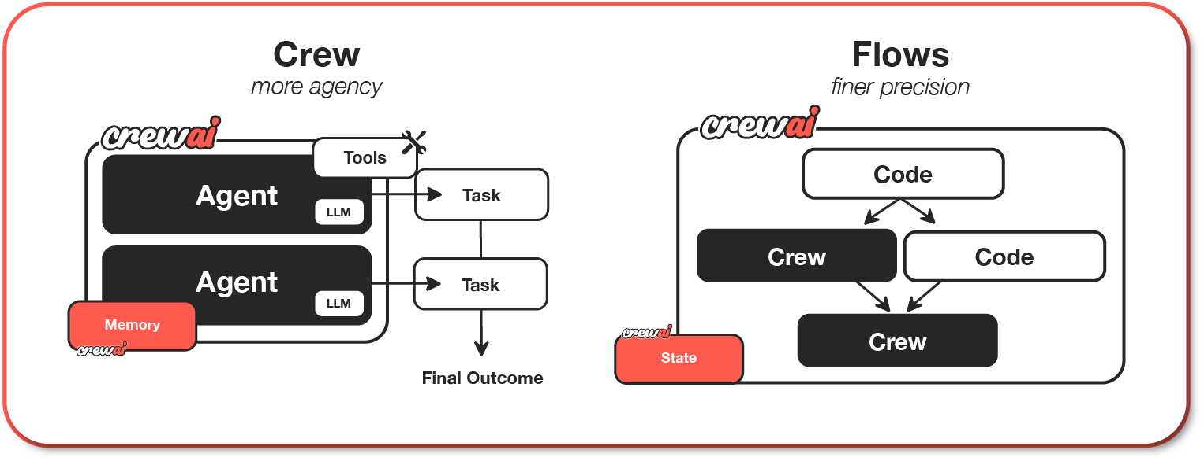
These core components provide the foundation for building intelligent, autonomous systems. With this understanding in place, we can now move on to constructing a single autonomous agent using CrewAI.

Setting Up Your Development Environment
Before building our agentic AI system, we need to ensure that our development environment is properly set up. CrewAI requires a few dependencies, and it is recommended to follow the official documentation for the most up-to-date installation instructions.
To install CrewAI and its dependencies, refer to the official CrewAI documentation. The documentation provides detailed steps for setting up the framework using various package managers.
Once you have CrewAI installed, you're ready to start developing your first agentic AI system.

Initializing a New CrewAI Project
NOTE: before starting using CrewAI, you would need to have an LLM provider API key, in order for the agents to work.
With CrewAI successfully installed, the next step is to initialize a new project. This will provide us with a basic structure and example files to start building our agentic AI system.
Use the following command to initialize a new CrewAI project:
crewai create crew my_agentic_project

Replace my_agentic_project with your desired project name. This command will generate a new directory with the project name and populate it with the necessary files and directories.
NOTE: You will need to select an LLM provider (OpenAI, Gemini, Groq, etc.) and the CLI will ask you for your API key.

Understanding the Generated Project Structure
After running the crewai create crew command, you'll find a new directory with the following structure:

- my-agentic-project
- knowledge
- src
- my-agentic-project
- config
- agents.yaml
- tasks.yaml
- tools
- __init__.py
- custom_tool.py
- __init__.py
- crew.py
- main.py
- tests
- .env
- pyproject.toml

The main files we will be paying attention to right now are:
- agents.yaml: This file will contain the definitions for your AI agents. Each agent will typically have its own definition, where you define its role, tools, and capabilities.
- tasks.yaml: Here, you'll define the tasks that your agents will perform. Each task will specify the instructions, inputs, and expected outputs for an agent.
- .env: This file is used to store your environment variables, such as API keys. CrewAI will automatically load these variables when your application runs.
- main.py: This file defines methods that can be executed from the CLI with the “crewai command”. Some of those methods are: run, train, test, replay.
- crew.py: It's where you'll create your agents, tasks and the crew.
- tools: In this folder we can define custom tools to expand the functionality of the agents.
- knowledge: This is the directory for the knowledge base used by the agents.

Demonstrating Core Agentic AI Concepts with CrewAI
In our previous article, "Understanding Agentic AI: Core Components Explained", we explored the fundamental concepts of Perception, Reasoning, Action, and Feedback. Let's see how these concepts manifest in a practical CrewAI example.

Single-Agent Example: Market Research
One of the use cases for Agentic AI is Content Creation. This can be applied to a lot of different areas: articles, books, reports, etc. Let’s use this last use case to demonstrate the power of CrewAI.
Imagine we want to create an agent that performs market research on a specific product and for a specific industry. We'll focus on demonstrating the core concepts.

- Perception:
  - The agent perceives information about the product from various sources, such as online articles, market reports, and customer reviews.
  - In CrewAI, this can be simulated by providing the agent with a task description that includes relevant search terms or URLs. Tools can play an important part here, but we will leave tools aside for now in this article.
- Reasoning:
  - The agent analyzes the perceived information, identifies trends, and draws conclusions about the product's market potential.
  - This involves using LLMs to process and interpret the data. As we saw in the article “Key Technologies Powering Agentic AI”, LLM’s are one of the main ones.
- Action:
  - The agent generates a market research report summarizing its findings.
  - This action is executed by the agent writing a document or outputting a structured data format.
- Feedback:
  - We can provide feedback by reviewing the report and highlighting areas for improvement or additional research.
  - This feedback can be used to refine the agent's reasoning and action in subsequent iterations or runs.
  - We can achieve this in CrewAI through the “train” method of the Crew class.

Here's how we can implement this in CrewAI:
- Define the agent: go to src/my_agentic_project/config/agents.yaml and define the agent as follow:

market_researcher:
role: >
{industry} Market Research Analyst
goal: >
Conduct thorough market research on a new product in the {industry} industry.
backstory: >
You are an experienced market research analyst with a focus on emerging technologies
in the {industry} industry.

As you can see, we have defined an argument {industry}. This will allow us to configure our market research analyst to be an expert in different industries.

- Define the task: go to src/my_agentic_project/config/tasks.yaml and define the task as follow:

research_task:
description: >
Conduct market research on the '{product_name}' within the {industry} industry.
Analyze online reviews, market reports, and competitor products.
Identify key trends and assess the product's market potential.
Generate a market research report.
expected_output: >
A comprehensive market research report that includes:
an executive summary, market analysis, competitor analysis,
trend identification, and market potential assessment.
Formatted as markdown without '```'.
output_file: single-agent-report.md
agent: market_researcher

We have added an additional argument “product_name” to parametrise the product we want to research. We have also specified the format of the output and in which file we want to save the results.

In case you would like to have more guidance on how to efficiently set agents and tasks, read these best practices from CrewAI.
- Create your crew: CrewAI is a framework thought for multi-agent systems. These systems are called crews. We will create a crew, but use only one agent for now. Go to src/my_agentic_project/crew.py and create your crew as follows:

from crewai import Agent, Crew, Process, Task
from crewai.project import CrewBase, agent, crew, task

# If you want to run a snippet of code before or after the crew starts,
# you can use the @before_kickoff and @after_kickoff decorators
# https://docs.crewai.com/concepts/crews#example-crew-class-with-decorators

@CrewBase
class MyAgenticProject():
"""MyAgenticProject crew"""

# Learn more about YAML configuration files here:
# Agents: https://docs.crewai.com/concepts/agents#yaml-configuration-recommended
# Tasks: https://docs.crewai.com/concepts/tasks#yaml-configuration-recommended
agents_config = 'config/agents.yaml'
tasks_config = 'config/tasks.yaml'

# If you would like to add tools to your agents, you can learn more about it here:
# https://docs.crewai.com/concepts/agents#agent-tools
@agent
def market_researcher(self) -> Agent:
return Agent(
config=self.agents_config['market_researcher'],
verbose=True
)

# To learn more about structured task outputs,
# task dependencies, and task callbacks, check out the documentation:
# https://docs.crewai.com/concepts/tasks#overview-of-a-task
@task
def research_task(self) -> Task:
return Task(
config=self.tasks_config['research_task'],
output_file='single-agent-report.md'
)

@crew
def crew(self) -> Crew:
"""Creates the MyAgenticProject crew"""
# To learn how to add knowledge sources to your crew, check out the documentation:
# https://docs.crewai.com/concepts/knowledge#what-is-knowledge

return Crew(
agents=self.agents, # Automatically created by the @agent decorator
tasks=self.tasks, # Automatically created by the @task decorator
verbose=True,
)

- Pass the custom inputs to your crew: go to src/my_agentic_project/main.py and modify the run method to look like this:

def run():
"""
Run the crew.
"""
inputs = {
'product_name': 'EduVerse', # --> Change it if you want
'industry': 'Immersive Educational Experiences' # --> Change it if you want
}

try:
MyAgenticProject().crew().kickoff(inputs=inputs)
except Exception as e:
raise Exception(f"An error occurred while running the crew: {e}")

- Check the result: run the following commands on the terminal. Make sure you are in the root of your project

crewai install
crewai run

You can find the result in a markdown file at the root of the project with the name “single-agent-report.md”. Here is the result itself:

# Market Research Report on EduVerse

## Executive Summary
EduVerse is an emerging immersive educational experience product designed to revolutionize how knowledge is imparted through advanced virtual and augmented reality technologies. This report presents a thorough analysis of online reviews, market trends, competitor products, and overall market potential. The demand for immersive education solutions has seen notable increases, particularly as remote and hybrid learning solutions become normalized. EduVerse holds significant promise in meeting educational needs globally.

## Market Analysis
The immersive educational experiences market has been experiencing robust growth. According to recent market reports, the global immersive education market was valued at approximately $1.8 billion in 2022, with expectations to grow at a compound annual growth rate (CAGR) of over 20% from 2023 to 2028. Key drivers include:

- **Technological Advancements**: Innovations in VR/AR have made immersive tools more accessible and effective.
- **Growing Distance Learning**: With remote education becoming mainstream, institutions are seeking engaging solutions.
- **Increased Investment**: Both public and private sectors are investing heavily in educational technologies.

Key segmentation includes K-12 education, higher education, and corporate training, with K-12 expected to dominate due to a growing emphasis on interactive learning.

## Competitor Analysis
Several prominent competitors exist in the immersive educational space that EduVerse must contend with:

1. **Nearpod**: A platform that combines interactive lessons with VR experiences, suitable for K-12 education.
2. **ClassVR**: Offers a comprehensive suite of VR tools for schools and educators focusing on content delivery.
3. **Immersive VR Education**: Known for VR-based training simulations, primarily for corporate and educational institutions.

EduVerse will need to differentiate itself by emphasizing unique features such as personalized learning paths, assessment tools, and scalable content creation to attract educators and institutions.

## Trend Identification
Key trends identified within the immersive educational experiences industry include:

- **Gamification of Learning**: Integrating gaming elements into educational content boosts engagement and retention.
- **Personalized Learning**: Customizable educational experiences tailored to individual learner's needs are gaining traction.
- **Collaboration Features**: Real-time interaction and collaboration tools are increasingly in demand to support group learning.
- **Data Analytics**: Focused interests in leveraging data to assess student progress and improve educational strategies.

## Market Potential Assessment
The market potential for EduVerse appears promising, with the following assessments supporting this outlook:

- **User Adoption**: Current online reviews indicate a positive reception toward immersive technologies in education, emphasizing user engagement and effectiveness.
- **Institutional Adoption**: Educational institutions are increasingly incorporating technology into curricula, with many seeking innovative tools to remain competitive.
- **Diverse Applications**: EduVerse can cater to a wide array of sectors, including K-12, higher education, vocational training, and corporate learning sectors.

Strategically leveraging trends and continuously innovating will be essential for EduVerse to thrive within this rapidly evolving landscape. The combination of increasing demand for personalized and engaging learning experiences positions EduVerse well for significant market capture.

## Conclusion
In summary, EduVerse occupies a favorable position to harness the expanding opportunities within the immersive educational experiences market. By capitalizing on growing technological advancements and educational needs, EduVerse can create a compelling offering that meets market demands. Continuous assessment of competitors and user feedback will be necessary to refine the product, ensuring its relevance and effectiveness in the education sector.

- Improving the agent through feedback: let’s assume we notice room for improvement in our report and we would like to tell that to the agent, so that it considers our feedback next time. To do so, let’s go to src/my_agentic_project/main.py again and modify the “train” method to look like this:
def train():
"""
Train the crew for a given number of iterations.
"""
inputs = {
'product_name': 'EduVerse', # --> Change it if you want
'industry': 'Immersive Educational Experiences' # --> Change it if you want
}
try:
MyAgenticProject().crew().train(n_iterations=int(sys.argv[1]), filename=sys.argv[2], inputs=inputs)

except Exception as e:
raise Exception(f"An error occurred while training the crew: {e}")
Now in the terminal we will execute the following command:

crewai train -n 3

This will tell CrewAI to start a training process with 3 iterations. The agent will request our feedback on each iteration and adapt the result to our feedback. During the iterations, I have provided the following feedback:
- Add how the recommendations can improve the product weaknesses
- In the competitor analysis, add how many users approximately each competitor has
- Add how many years in the market each competitor is
On each iteration, the agent will listen to your feedback and show to you an improvement on the previous result. The final result after the training in my example was the following:
# Immersive Educational Experiences Market Research Report: 'EduVerse'
## Executive Summary
The 'EduVerse' is positioned as a groundbreaking product in the Immersive Educational Experiences industry, integrating cutting-edge technology such as VR and AR to improve learner engagement and knowledge retention. This report delves into the current market landscape, competitor offerings, user feedback, key trends, and potential growth opportunities for 'EduVerse.' Insights from online reviews, market reports, and an analysis of competing products will guide recommendations to enhance the product's features.
## Market Analysis
### Industry Overview
The Immersive Educational Experiences industry has witnessed growth owing to the increasing adoption of technology in education. The market is expected to grow significantly in the next 5 years, with projections suggesting a CAGR of over 25% due to increasing demand for remote learning and a shift toward experiential education.
### Target Market
The primary target market for 'EduVerse' includes educational institutions (K-12 and higher education), corporate training sectors, and individual learners looking for innovative learning solutions.
### User Demographics
Feedback suggests that current users of immersive experiences are predominantly tech-savvy individuals aged 18-34, alongside a growing interest from educators and training professionals across varied industries.
## Competitor Analysis
### Major Competitors
1. **ClassVR**
- Users: Approximately 30,000 users
- Years in Market: 4 years
- Strengths: Robust hardware offerings and extensive content library.
- Weaknesses: Higher pricing and limited customization options.
2. **zSpace**
- Users: Approximately 20,000 users
- Years in Market: 7 years
- Strengths: Strong emphasis on STEM education and interactivity.
- Weaknesses: Less focus on social and emotional learning elements.
3. **Everfi**
- Users: Approximately 15,000 users
- Years in Market: 10 years
- Strengths: Broadly recognized for financial literacy and social issues educational content.
- Weaknesses: Less integration with immersive technologies compared to peers.
4. **Engage**
- Users: Approximately 10,000 users
- Years in Market: 3 years
- Strengths: Collaborative and multi-user capabilities appeal to remote learning.
- Weaknesses: Less comprehensive curriculum content compared to competitors.
### Competitor Positioning
The competitive landscape shows a mixture of established players and newer entrants. 'EduVerse' must differentiate through unique content offerings and user engagement features to capture market share.
## Trend Identification
1. **Increased Adoption of VR/AR**: Educational institutions are rapidly adopting VR and AR technologies to enhance teaching methodologies.
2. **Gamification in Learning**: Educators and learners prefer gamified experiences that improve engagement.
3. **Focus on Social-Emotional Learning**: Products integrating social-emotional learning components are gaining traction.
4. **Need for Customization**: There is a high demand for personalized learning experiences tailored to individual learner needs.
## Market Potential Assessment
The potential market for 'EduVerse' is substantial, with projections indicating that immersive technologies in education could exceed $20 billion by 2028. Factors contributing to this potential include:
- Expanding online education due to global digitalization.
- Increased investment in educational technology post-pandemic.
- A growing preference for blended learning environments among educators.
## Recommendations
1. **Enhance User Customization**: Introduce customizable learning pathways that adapt to different learning speeds and styles, overcoming a key competitor weakness.
2. **Integrate Social-Emotional Learning Modules**: Develop content that aligns with emotional intelligence to attract a broader user base, as seen with successful competitors like Everfi.
3. **Focus on Affordability**: Balance features with pricing to make 'EduVerse' more accessible to institutions and individual learners, thus widening the target market.
4. **Leverage Data Analytics**: Utilize analytics to offer insights into user engagement and learning outcomes, improving the platform based on user feedback and performance data.
By implementing these recommendations, 'EduVerse' can enhance its product offerings, address existing weaknesses, and ultimately capture a larger portion of the immersive education market.

As you can observe, in the competitor analysis, we now have the number of users and years of the product in the market. Also, the recommendations section is linking the suggestions to overcome competitors' weaknesses. This shows our feedback was considered by the agent.
What is more, the framework has now created a file where the feedback instructions are used by the agent in a summarized way. If you pay attention, you will now find a file at the root of your project called “trained_agents_data.pkl.” This file contains serialized Python objects that will from now on be used by the agent on every execution. Here is how mine looks like:

Item 1/1:
{'Immersive Educational Experiences Market Research Analyst\n': {'suggestions': ['Incorporate user demographics and feedback into the market analysis section for a more comprehensive overview.', 'Add user base statistics for key competitors to highlight market position.', 'Include the number of years each competitor has been in the market to contextualize their experience and stability in the field.', 'Make sure to clearly outline specific competitor strengths and weaknesses to aid in differentiation strategies in future reports.', 'Elaborate on how proposed recommendations can effectively address existing weaknesses outlined in the SWOT analysis.'], 'quality': 9.0, 'final_summary': "1. Include user demographics and feedback in the market analysis section. 2. Provide competitor user base statistics and years in the market. 3. Summarize competitors' strengths and weaknesses concisely. 4. Describe how each recommendation addresses identified weaknesses. 5. Continue refining the ability to incorporate feedback for improved output quality."}}

We have provided this feedback through offline training, but in real projects, we can easily implement the training programmatically in real-time. Since the feedback is saved in a separate file, it would be as easy as simply deploying the updated file to the agent in order to provide the feedback.
This opens the door to even more advanced use cases: can you imagine how great it would be to have a second crew that acts as a Quality team and provides constant feedback to the rest of the agents? And all of this in real time?

Conclusion
This first part of our CrewAI journey showcased the power of a single agent, exemplified by our "EduVerse" market research analyst. We explored parameterizing agent roles, defining expected outputs, and even simulated learning through manual offline feedback. These techniques highlight CrewAI's ability to orchestrate autonomous tasks, laying the groundwork for more complex scenarios. The single agent's success underscores the framework's potential for focused, efficient AI applications, demonstrating how clear task definitions and simulated memory can enhance agent performance.
However, the true potential of Agentic AI lies in collaboration. As we move into the second part, we'll expand this example into a multi-agent system, demonstrating how CrewAI orchestrates complex task flows and manages dependencies. This transition will unveil the framework's ability to mirror human teamwork, unlocking new levels of efficiency and innovation. Prepare to witness how CrewAI's dynamic capabilities can elevate AI applications beyond single-agent limitations, showcasing the real magic of collaborative agentic systems.

Agentic AI in Action: Building with CrewAI - Part 2

Objective
Teamwork makes the dream work—especially in AI! See how CrewAI transforms a lone agent into a powerhouse team, crafting a full content package. Witness the magic of multi-agent collaboration and unlock new creative AI possibilities. Level up your AI game!

Introduction
In Part 1, we focused on a single agent, a market research analyst, tasked with investigating a product (the "EduVerse" immersive educational platform, in our case). Now, we'll expand this example to demonstrate how multiple agents can collaborate to create a comprehensive content package around the chosen product. This shift allows us to explore a different aspect of CrewAI's capabilities: its potential for creative and collaborative tasks.

Expanding to a Content Creation Crew for EduVerse
Instead of focusing solely on market analysis, we'll create a crew (multi-agent AI system) designed to produce a range of content for "EduVerse." This crew will leverage the single-agent's initial research and expand upon it.
Our "EduVerse" content creation crew will consist of the following agents:
- Market Research Analyst: (From Part 1) Provides the foundational market research and insights.
- Content Strategist: Develops a content strategy based on the market research, identifying target audiences and key messaging.
- Technical Writer: Creates detailed technical documentation and specifications for the "EduVerse" platform.
- Creative Writer: Crafts engaging marketing copy, blog posts, and social media content to promote "EduVerse."
We'll define specific tasks for each agent and establish a multi-agent crew that will allow them to collaborate with each other to achieve the final goal.
- Market Research Task: (Assigned to Market Research Analyst) Provide the research report from the previous article.
- Content Strategy Task: (Assigned to Content Strategist) Develop a content strategy based on the market research, outlining target audiences, key messages, and content formats.
- Technical Documentation Task: (Assigned to Technical Writer) Create a comprehensive technical documentation for the "EduVerse" platform, including specifications, user manuals, and troubleshooting guides.
- Creative Content Task: (Assigned to Creative Writer) Produce engaging marketing copy, blog posts, and social media content to promote "EduVerse."
Here is how the code looks like for both, agents and tasks:
- src/my_agentic_project/config/agents.yaml:
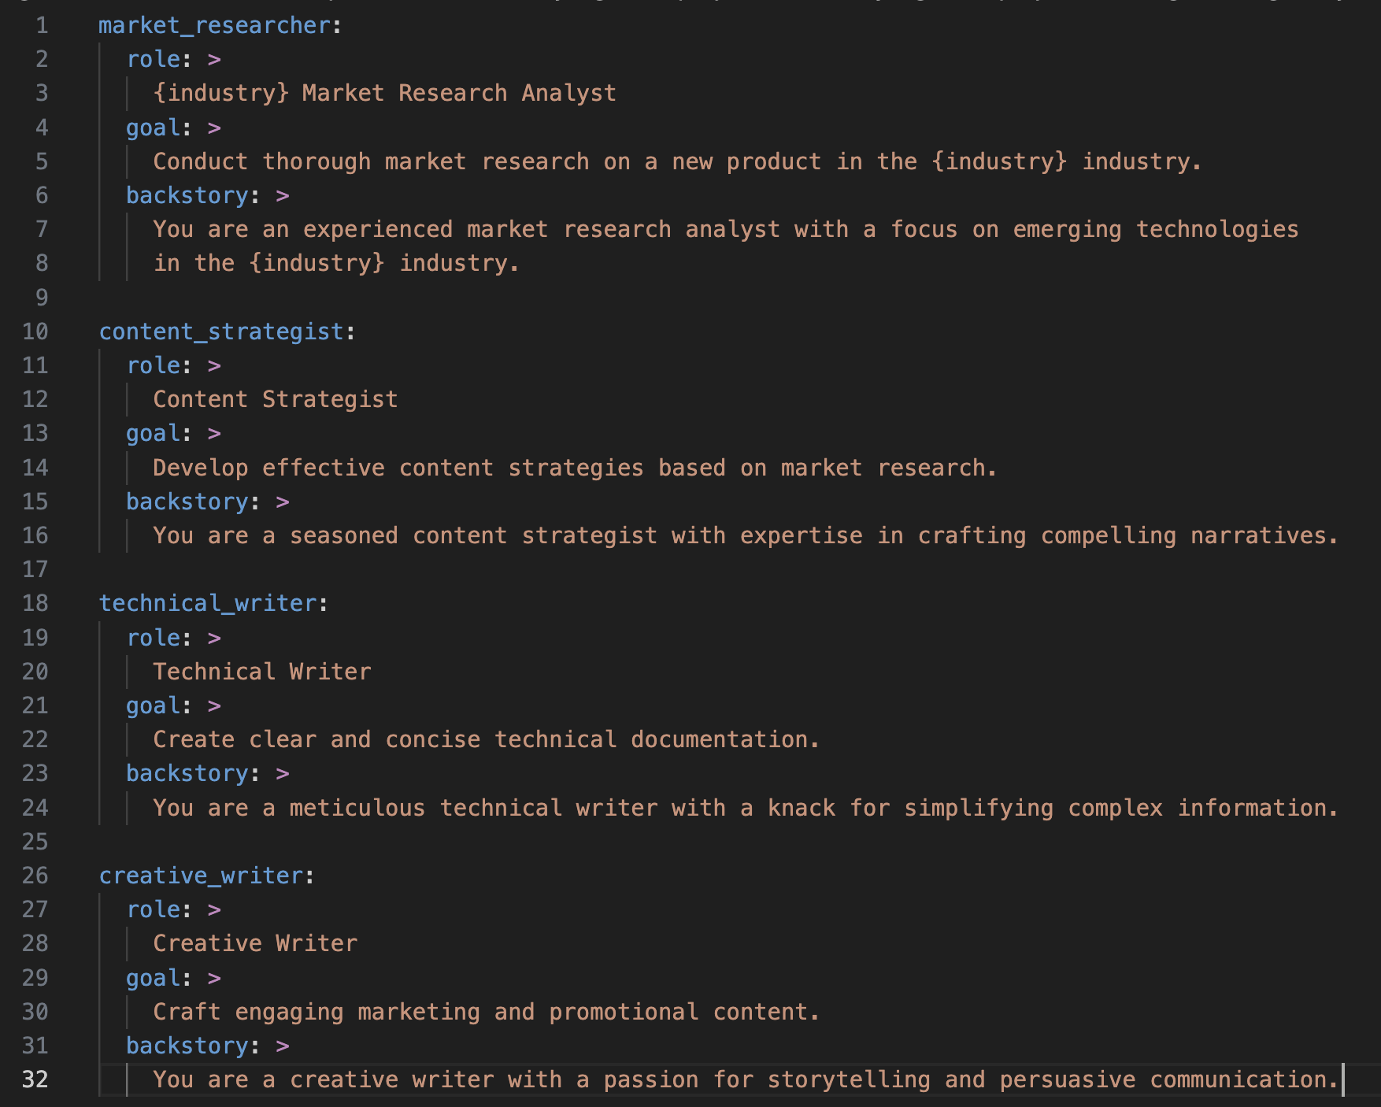
- src/my_agentic_project/config/tasks.yaml:

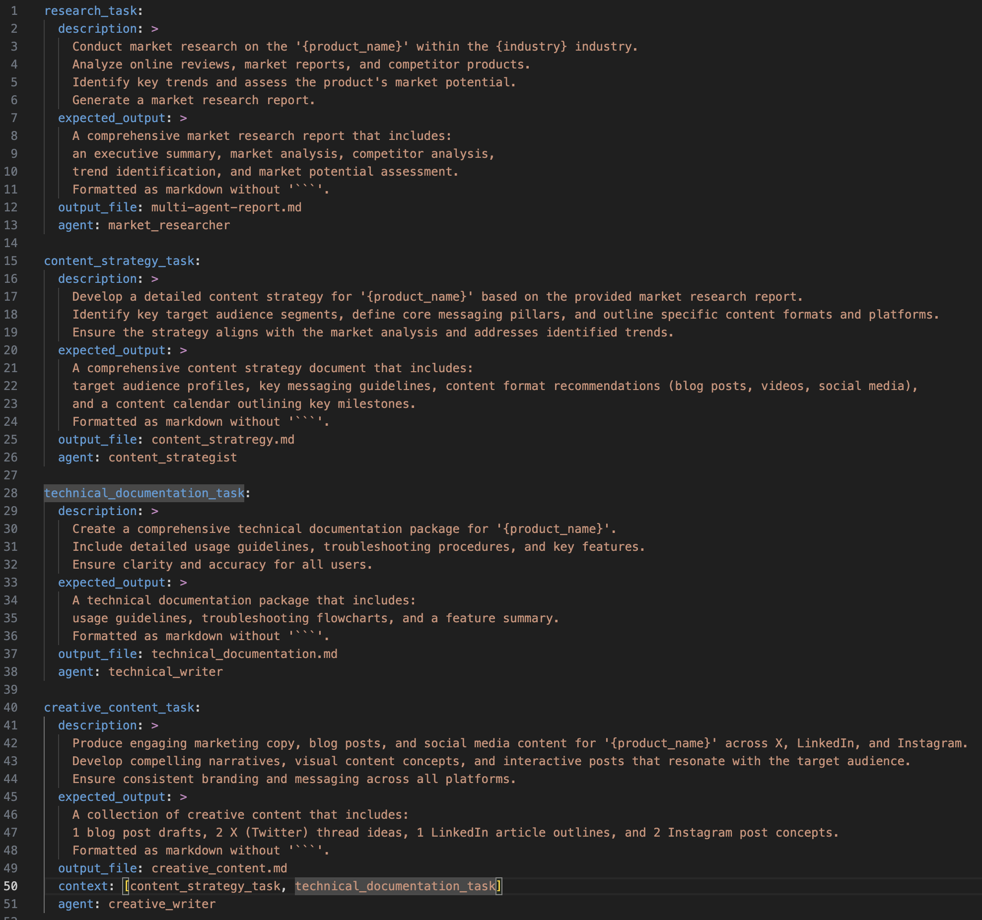
We have to assign the corresponding agent that will execute the task. Also, as you can observe, the “creative_content_task” has the attribute “context”. This allows us to specify which tasks’ results should wait to be ready before starting the task. You can think of it as some sort of task dependency.
Do not forget to update your main.py file, where we create the new agents, tasks and the complete crew:
- src/my_agentic_project/crew.py
Run the crew:
crewai run
And check the result of each task. Here are mine:
- Market Research Report
- Content Strategy
- Technical Documentation
- Creative Content
The power of combining agents becomes evident when we see the comprehensive content package generated. By allowing each agent to focus on their specialized task, we've created a far more detailed and effective result than any single agent could have achieved alone. This demonstrates the potential of CrewAI to tackle complex, multi-faceted projects through collaborative intelligence.

Advanced Use Cases in CrewAI with Multi-agents Systems
Now that we've built a foundational multi-agent system, let's explore some advanced use cases that showcase the true potential of CrewAI.
- Crew Process: Orchestrating Complexity
  - In our previous example, the agents executed tasks in a sequential order, the default behavior of CrewAI. But what if you need more nuanced control? CrewAI also supports a "hierarchical" process, where a designated agent, or even a powerful LLM, acts as the conductor, managing the entire crew. Imagine an AI orchestrator, dynamically assigning tasks and adapting workflows in real-time. This opens up possibilities for incredibly complex and adaptive multi-agent systems. Ready to see your agents operate with a new level of intelligence?
- Tool Augmentation: Supercharging Your Agents
  - Agents are powerful on their own, but what if they could access external data and functionality? CrewAI allows you to equip your agents with "tools," extending their capabilities beyond pure language processing. Think of tools as superpowers: web search, data analysis, API integrations—the possibilities are endless. Imagine your agents seamlessly pulling real-time data, analyzing complex datasets, or interacting with external systems. It's time to unleash the full potential of your agents!
- Task Delegation: Dynamic Workflows
  - CrewAI enables dynamic task delegation, where agents can assign tasks to each other based on real-time conditions. This allows for flexible and adaptive workflows, where agents can collaborate and distribute workload efficiently. Imagine a crew where agents autonomously decide who is best suited for each task, optimizing performance and maximizing efficiency. This is collaborative AI at its finest.
- Flows: Blending Code and Crews
  - CrewAI's "flows" feature allows you to seamlessly integrate Python code into your multi-agent workflows. This means you can create highly customized and controlled processes, combining the power of code with the intelligence of your agents. Imagine being able to create complex conditional workflows, or looping processes, all inside of your crew definition. It is a tool for the advanced user that wants to have full control of their crews.
- Multimodal Agents: Beyond Text
  - While we've focused on text-based interactions, CrewAI is designed to support multimodal agents. This means your agents can process and generate various types of data, including images, audio, and video. Imagine agents that can analyze visual content, generate audio summaries, or even create video presentations. This opens up a whole new world of creative and innovative applications.
These advanced use cases are just the tip of the iceberg. CrewAI empowers you to build sophisticated and dynamic multi-agent systems that can tackle complex challenges with intelligence and efficiency. We encourage you to explore these features and discover the endless possibilities of collaborative Agentic AI.

Conclusion: Building Foundations, Bridging Futures
With this exploration of multi-agent systems using CrewAI, we conclude our "Foundations of Agentic AI" module. We've traversed from defining Agentic AI's core principles to practical application, demonstrating CrewAI's capacity for creating collaborative AI crews. We've dissected perception, reasoning, action, and feedback, and illustrated CrewAI's versatility through the "EduVerse" content creation example.
This module has established a solid base for understanding how Agentic AI transcends mere automation, enabling systems to decide, adapt, and collaborate. However, this is just the beginning. In our next article, we will delve deeper into the technologies and concepts that make these systems possible. We will explore Large Language Models (LLMs), Retrieval Augmented Generation (RAG), multimodal agents, tool augmentation, and more. This will be an opportunity to further understand the building blocks of autonomous intelligence and how they can be leveraged to create even more sophisticated applications. Stay tuned as we continue to push the boundaries of Agentic AI.

